**Project Development Phase Delivery of Sprint-1**

|  |  |
| --- | --- |
| **Date** | **07 November 2022** |
| **Team ID** | **PNT2022TMID10019** |
| **Project Name** | **Analytics for Hospitals' Health-Care Data** |

**Project Development Phase:**

|  |  |
| --- | --- |
| **Sprint-1:**   * Data Collection * Data Preparation   **Sprint-2:**   * Data Exploration | **Sprint-3:**   * Dashboard Creation   **Sprint-4:**   * Report Creation * Story Creation |

# TEAM ID: PNT2022TMID10019

**TEAM MEMBERS :**

**NAVEEN KUMAR R**

**MUHAMAD TAWFEEQ**

**NARESH KUMAR**

**MUGESHKUMAR**

**Sprint-1:**

## **Data Collection**: Download the Dataset Dataset link : https://drive.google.com/file/d/1slC0MhsJHeuODVkhIXrdNOX_aBDySSBh/view?usp=share_link **Load the Dataset: Tool used:** IBM Cognos Analytics

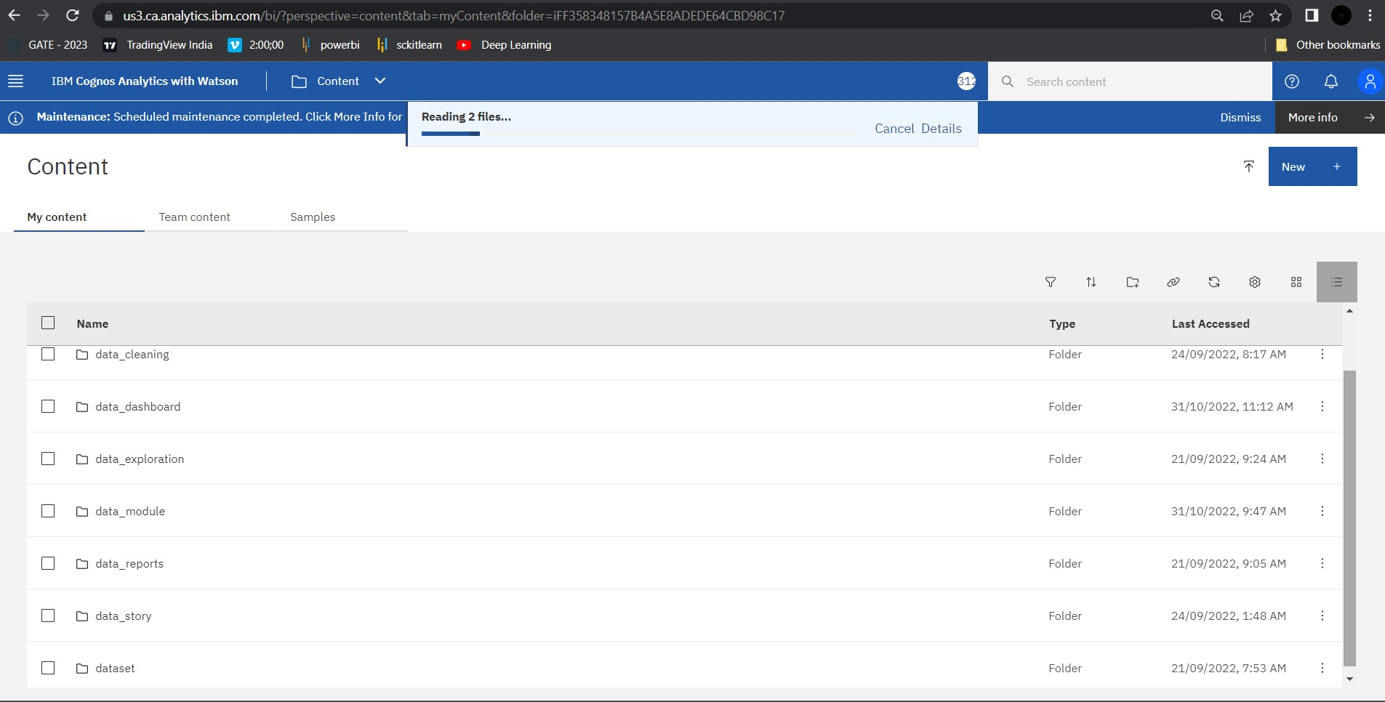

**Data Preparation:** Prepare the Dataset

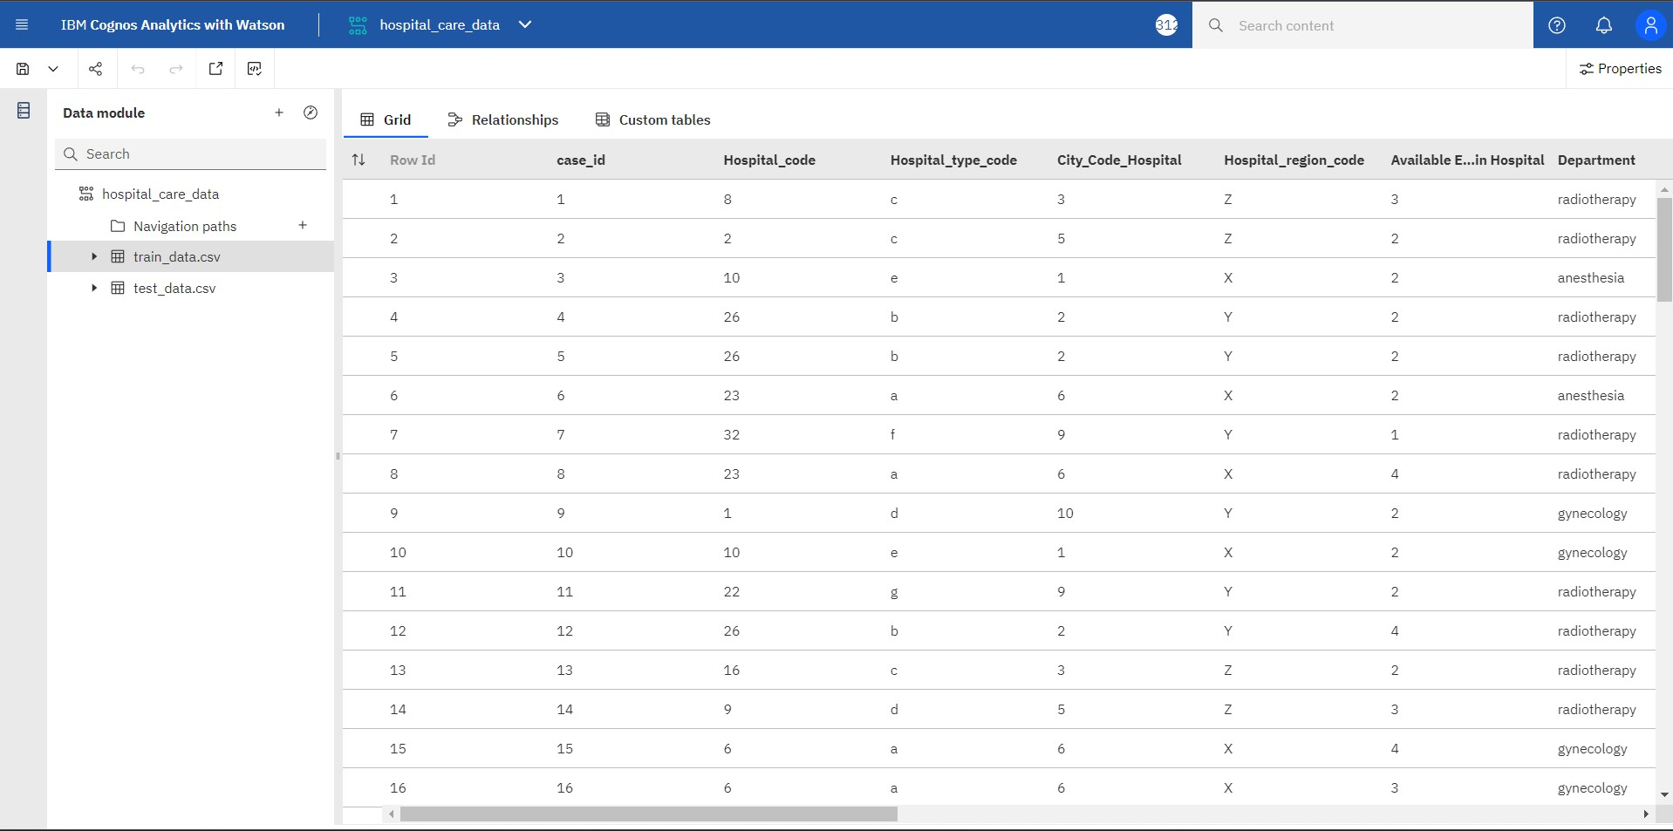

**Null Values Cleaning Process :**

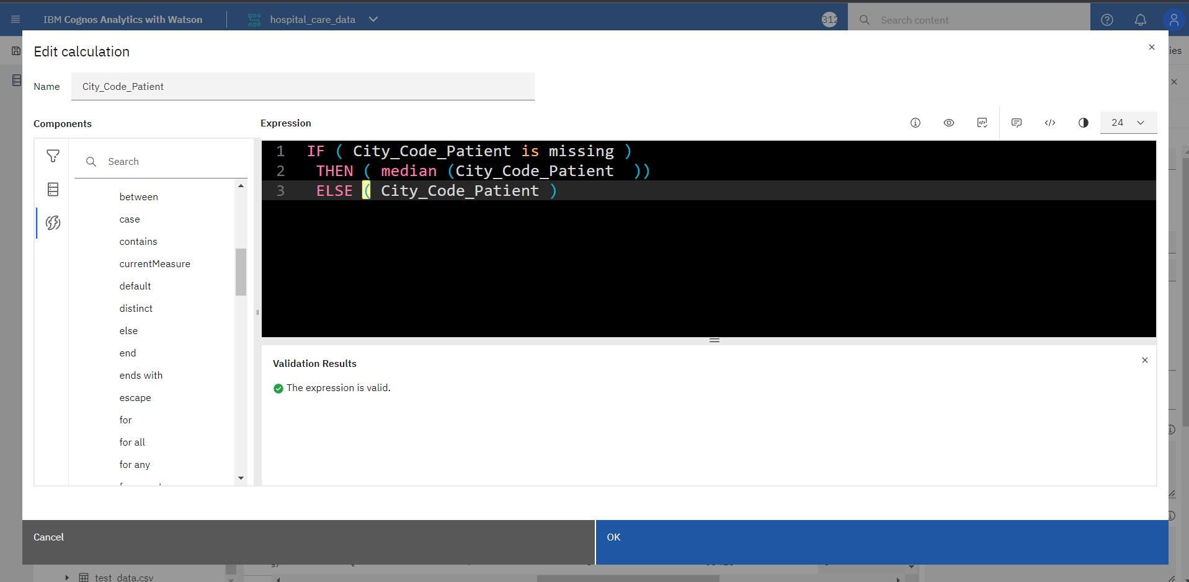

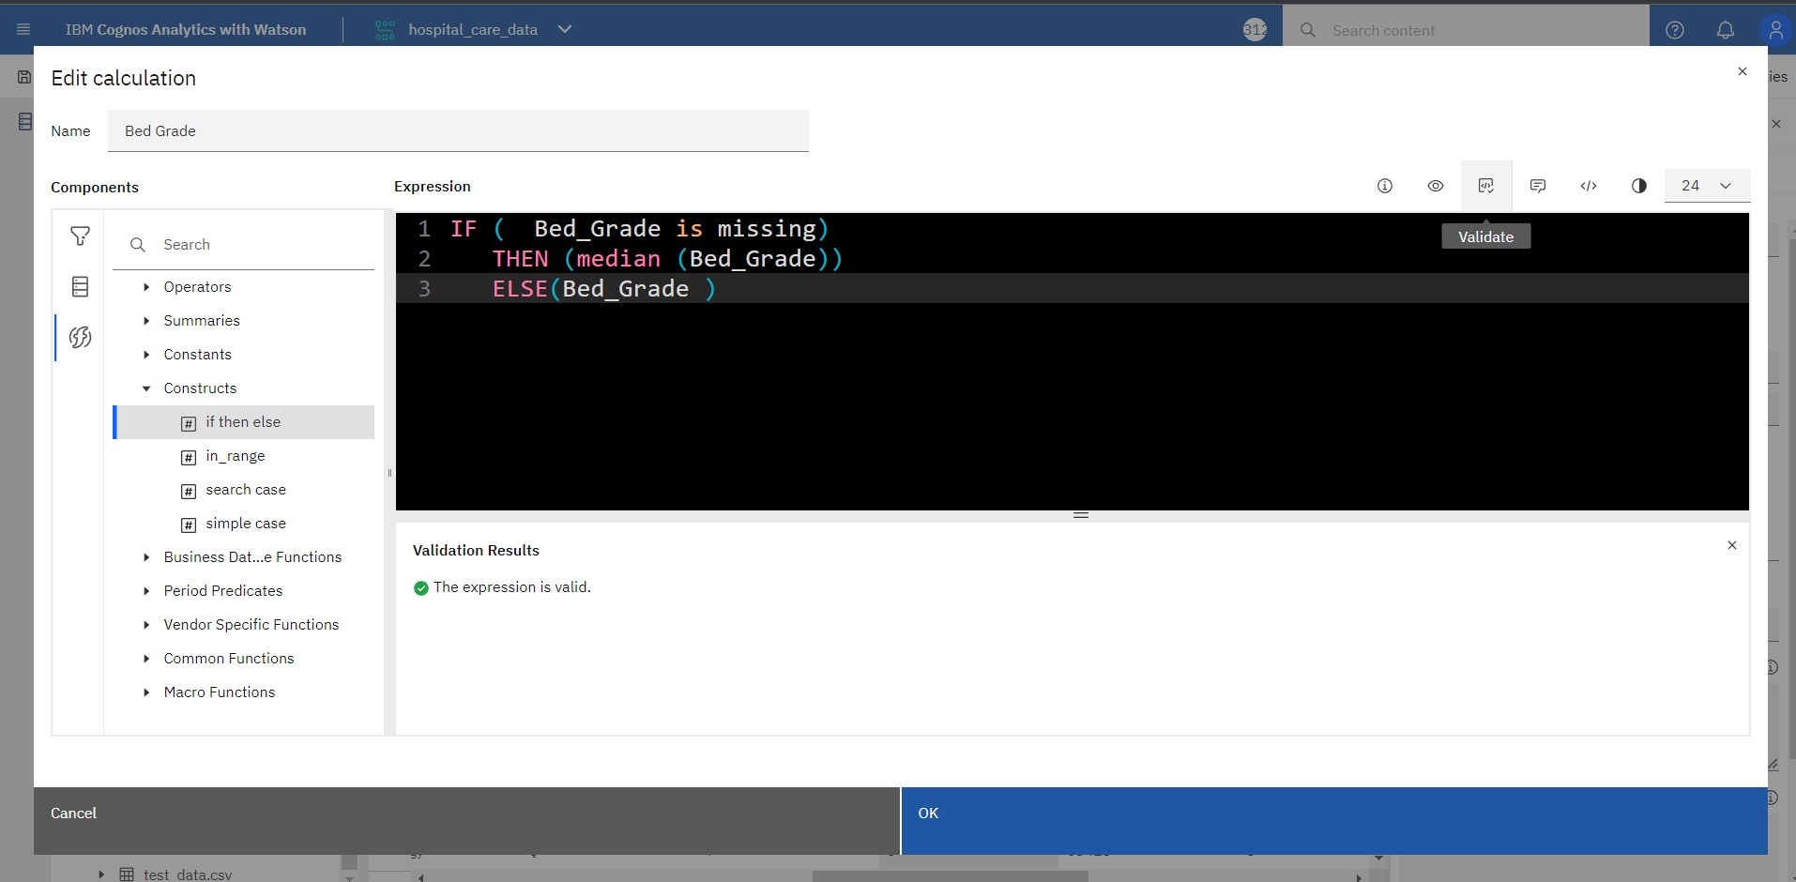

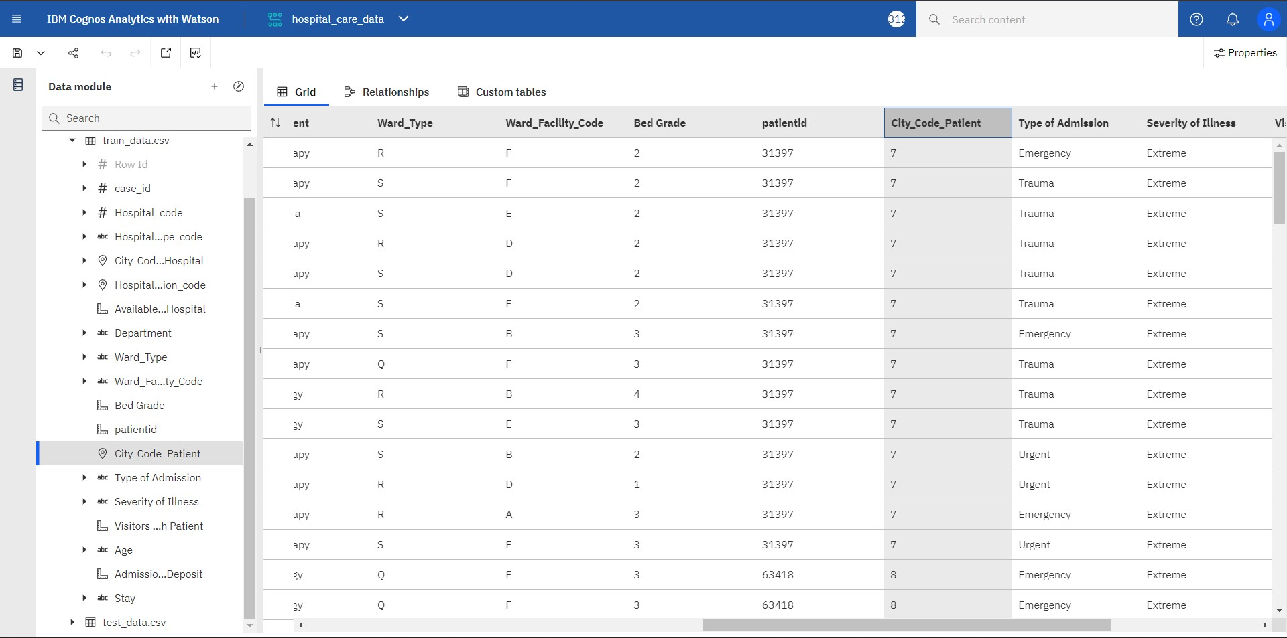

**Hospital Data :**

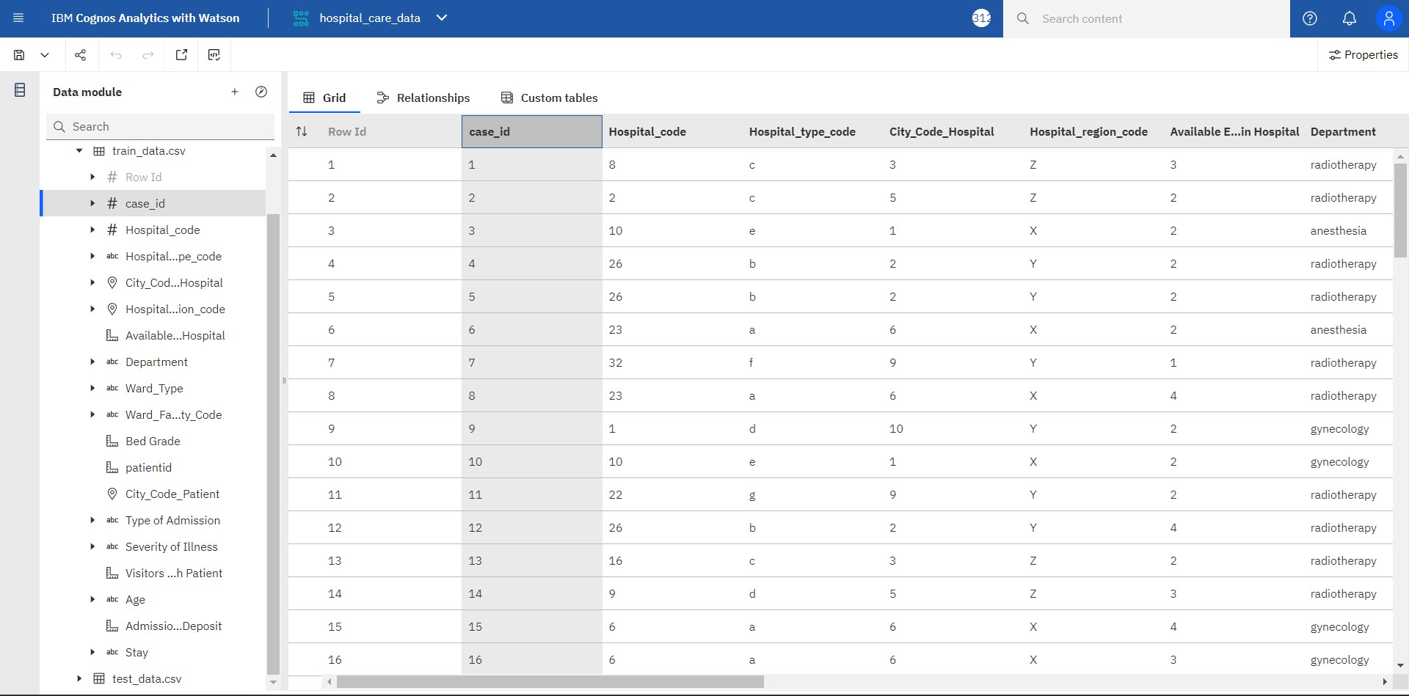

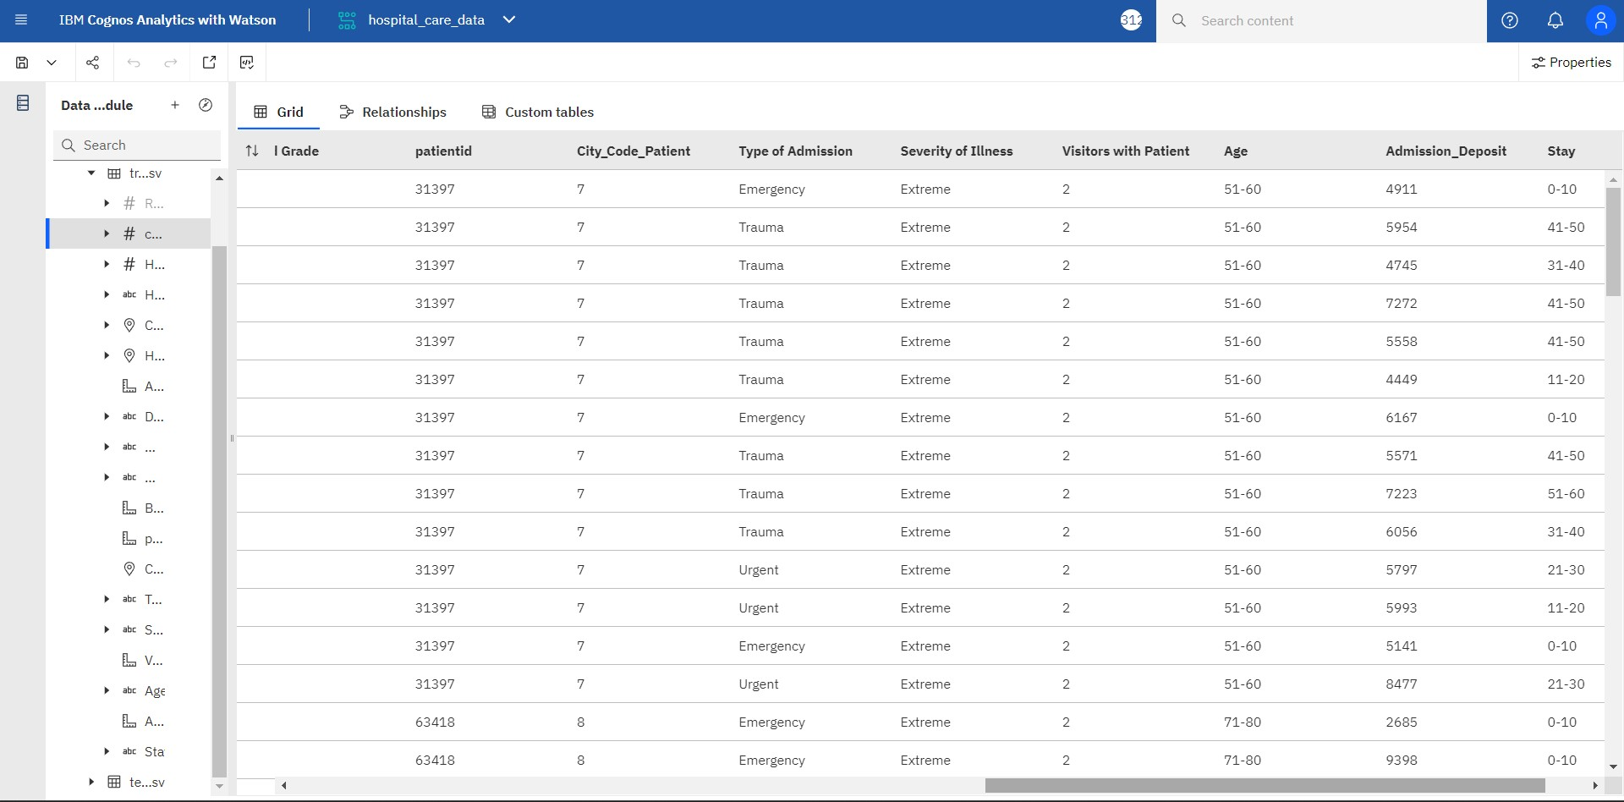

**Prepared data link :** <https://us3.ca.analytics.ibm.com/bi/?perspective=camodeller&pathRef> =.my_folders%2Fdata_module%2F hospital_care_data

